**sss**

**NAME : Varsha.R**

**DEGREE**  **:** **BSC.Computer Science**

**Email : varsha@gmail.com**

**Mobile :+91-9025017685**

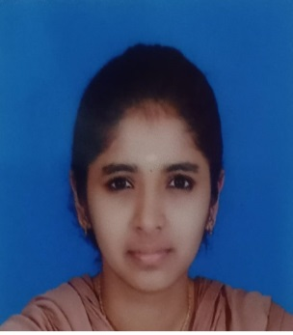

|  |  |
| --- | --- |
| **Father’sname**  **Gender**  **Date of Birth**  **Languages Permanent Address** | * Ramesh.L * Female * 03 October 2003 * Tamil,English.   **:** 2/287-47 iyyapanagar,  Pongalur, Palladam(tk),Tirupur(dt)-641667. |

**CAREER OBJECTIVES**

To make use of my interpersonal skills to achieve goals of a company that focuses on customer satisfaction and customer experience.

**Academic Record**

|  |  |  |  |  |
| --- | --- | --- | --- | --- |
| **Course** | **Institution** | **Board** | **Completion By** | **Marks (%)** |
| **BSC(CS)** | L.R.G.Government Arts College For Women Tirupur-641667 | Bharathiyar University | 2024 | 90 |
| **XII** | PVKN.Hr.Sec.School pongalur | Stateboard | 2020 | 95 |
| **X** | PVKN.Hr.Sec.School pongalur | Stateboard | 2018 | 92 |

**AreaS of Interest**

* PROGRAMM

**Skill Set**

|  |  |
| --- | --- |
| 1. Operating systems | Windows, Linux, Ios,I mac |
| Other software’s | 1. MS office 2. Corel Draw 3. Photoshop |

**Declaration**

I, varsha, do hereby confirm that the information given above is true to the best of my knowledge.

**Place:**

**Date:**

( VARSHA R)